CONFINDUSTRIA-SRM - CHECK UP MEZZOGIORNO: Positive results for private investment and tourism, the Mezzogiorno is on the move
2017 ended with a moderate but steady improvement of Southern economy. This is confirmed by the Check Up Mezzogiorno of December 2017, the traditional study carried out by Confindustria and SRM, Studi e Ricerche per il Mezzogiorno (research centre of the Gruppo Intesa Sanpaolo).
After a 2016 where the Southern regions grew in line with the national average, the expectations related to 2017 confirm the growth trend, which should carry on also in 2018, with a GDP increase higher than 1%. The indices for trust, being close to the maximum values, confirm this moderately positive situation.
This trend is confirmed by the Synthetic Index of Southern Economy, elaborated by Confindustria and SRM, which shows that every indicator is growing. The GDP of the Mezzogiorno has increased for the second year in a row (+1%): the investment is also increasing again, driven by private ones, especially by the ones related to industrial sectors, which, only during this last year, have had a 40% increase on the previous year. Although this is still not enough to return to the values of 2007, it’s still a significant leap forward.
The recovery has been confirmed to be mainly in the hands of the companies: the number of active ones, in the third trimester of 2017, has increased by about 7thousand units (+0.4%) compared to the same period of 2016, and this trend is even more significant when compared to the simultaneous decrease that occurred in the rest of the Country (-0.1%). In particular, the increase of capital companies carries on (+17 thousand in the III trimester of 2017 on the same period of the previous year), with almost two times the pace of the Centre-North, and at the same time the share of companies with a number of employees between 10 and 49 has increased again (+0.2%), two clear signals of the strengthening of the productive fabric.
This fabric has been increasing its dynamism: the number of innovative startups is rising (31.1% more in the II trimester of 2017 on the same period of the previous year), a better data than the one registered in the Centre-North (+22.4%), with a positive trend for all the regions of the Mezzogiorno. There are also positive results on the data related to networking companies (which are now almost 6,000, 1,000 more during the second part of the year) and youth companies (more than 252,000 in 2016, 41.5% of the national total) and female businesses (more than 3,000 more during just the II trimester of 2017).
A robust contribution to the dynamism signals of the productive system of the South is also coming from export: compared to the III trimester of the previous year, the export of the companies of the Mezzogiorno increased by 8.6%, with a superior pace than the Centre-North (+7.2%). With the exception of means of transportation and electronic apparel, the export of every product sector is increasing, with a particular intensity for refining products (+42.9%), chemical products (+21.6%) and pharmaceutical ones (+9.4%).
A significant impact on the positive results of the entrepreneurial fabric of the South comes from the tourism sector, to which the Check Up dedicates a specific in-depth analysis. 2016, in fact, has seen an increase of arrivals and stays of tourists in every Southern region (+4.3%, 1 point and half higher than the Centre-North). The so-called “tourist export” has particularly increased, i.e. stays (+7.8%) and expenditure (+24%) of foreign tourists. At the basis of these positive results there are the Southern tourism companies, which, although they only represent 25% of the national total (20% of Italian accommodation companies), constitute a very steady sector, with more than 70 thousand employees and two billion and half of value added, whose profitability has been steadily improving since 2012, while debt and the related financial expenses are decreasing. The sector has a very high-quality offer (the hotels of the 4 – 5 stars segment are almost two times the national average) and important niches, such as thermal industry, which gathers ¼ of the income of the whole national thermal industry.
2017 is a moderately positive year as far as employment is concerned: also thanks to the support of the employment Bonus, the Mezzogiorno has recorded percentage increases of the employees higher than the ones of the Centre-North, with a growth, in absolute values, of over 108 thousand units in the III trimester of 2017 on the same period of the previous year. However, while they have handily surpassed the 6 million threshold, the employees of the South are still 230 thousand less than the pre-crisis peak.
The quality and the efficiency of the educational system in the South, though, is still one of the critical factors. In fact, the share of Southern young people that don’t study and don’t have a job is still very high (they are over 1 million and 800 thousand, almost 60% of the national total), and 200 thousand of them don’t possess a degree, which is a waste of educational investment. This causes a widening of the gap between those who take up the residence in the South and those who leave it, with a negative balance of over 62 thousand units.
The incidence of poverty is decreasing, albeit slowly, with the exception of the 35-44 age range, a phenomenon that highlights the increasing difficulty of finding a job for those who are not so young anymore but are still far away from retirement age. The percentage of Southern citizens that consider their financial situation as very or partially satisfying is rising (+2%), but it’s still 11 points behind the national average.
The economic situation of Southern regions appears to have settled, therefore, on a new set of standards and to have improved slightly, which, however, is still not enough to effectively take down the unease still pervading the majority of Southern society, also because the economy of the South is hindered from reaching its true potential by several factors:
- a post-crisis composition of the Southern productive fabric characterized by a high number of small and very small-sized companies, which contribute, despite themselves, at keeping productivity low;
- an extreme territorial diversification, which shows the picture of a Mezzogiorno with different speeds:
- the low competitiveness of the territories, as shown by the scores obtained by Southern regions when calculating many indicators composing the regional Competitiveness Index of the European Commission.
- credit: the credit conditions in the South are improving, but not for everyone, and while the credit offer has loosened some, is still not able to meet the demand properly.
- the insufficient contribution of the public expense for investment, confirmed by the estimates of the Territorial Public Accounts for 2016, that highlight a new contraction of capital expenditure of the P.A. net of financial items, which reached its lowest point of the last 15 years, going from 15 to 13 billion, over 11 billion less than 2002. In particular, the halving of the expenditure for additional resources has affected this situation, due to the slow start of the new programming cycle of structural funds. The very recent CPT estimates on the performance of the first months of 2017, unfortunately, confirm this trend.
The Mezzogiorno continues to rise: the results achieved during the last two years and the estimates for the next one seem to confirm that the recovery of the economy of the South has steadily matched the one of the rest of the Country, despite the many halting factors. And the better results of many Southern regions, although they stem from different contexts, on the rest of the Country, seem to confirm that there is a real potential for decreasing the gaps. The conditions for a more robust recovery, happening as early as 2018, are also all in place, thanks to the recent provisions for the South and the actual start of the 2014-2020 Programmes by the Regions, which are creating the conditions for real, advantageous investment in the Mezzogiorno.
The coincidence of favourable conditions and the entrepreneurial dynamism can turn 2018 into a pivotal year for the outlook of the economy of the Mezzogiorno.
There are three contexts that are capable of affecting, in one way or the other, this pivotal point: the support to private investment: the recovery of public investment: a steadily competitive context. And there is just one policy capable of favouring simultaneously these three key elements: the cohesion policy, both from the Community and the nation, i.e. the main investment policy of the European Union. And 2018 is the crucial year when the concrete effects of the interventions of the current programme are going to appear, and to set the basis for a post-2020 outlook that can be both stable and real.

Synthetic index* of the main economic variables in the Mezzogiorno between 2007 and 2017
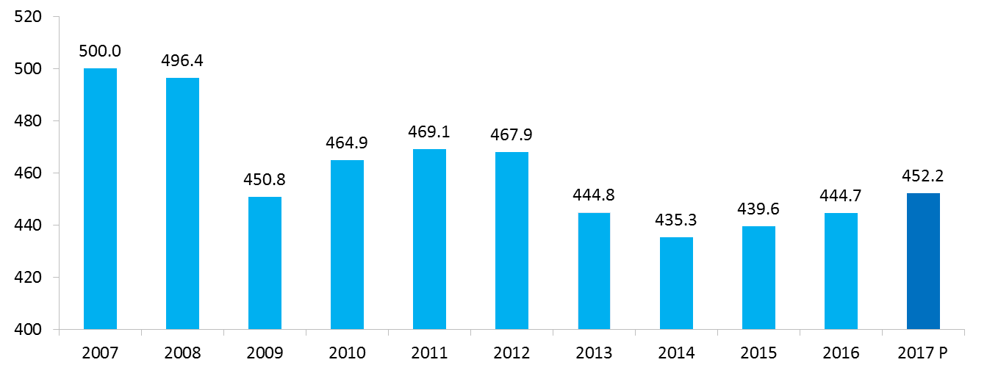
*The composite index is calculated as the sum of the values index-linked up to 2007 of some important macroeconomic variable: GDP (chainlinked values, base year 2010), gross fixed Investment, active companies, Export.
Source: Confindustria and SRM elaborations on various data

Composition of the Synthetic Index*
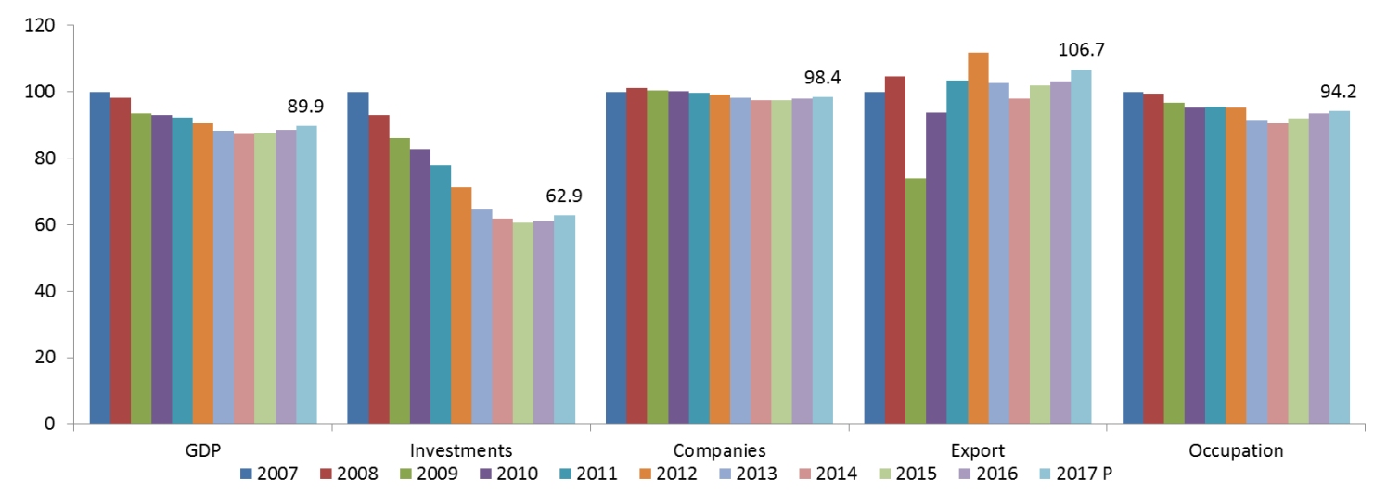
*Estimated values for investment
Source: Confindustria and SRM elaborations on various data

Consensus on GDP forecasts for 2017 and 2018 by macroarea (percentage values)
 | 2017 | 2018
North West | 1.4 | 1.4
North East | 1.5 | 1.5
Central Italy | 1.4 | 1.2
Southern Italy | 1.3 | 1.1
Italy | 1.5 | 1.4
Source: Confindustria and SRM elaborations on various data

Growth rates of number of companies* 2010-2017, comparison between Mezzogiorno and Centre-North
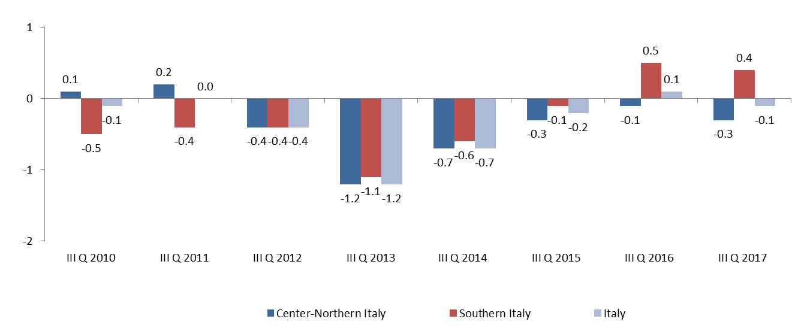
* Active companies; trend growth rates (III trimester on III trimester of the previous year)
Source: Confindustria and SRM elaborations on Movimprese data

Gross fixed investment per branch of activity in the Mezzogiorno and the Centre-North (2000-2016)
 | 2016  (current millions €) | Var. % | 2016 | Var. %
 |  | 2000/2006* |  | 2000/2006*
 | Mezzogiorno |  | Centro-Nord
Agriculture, forestry and fishing | 2,202 | -40.9 | 7,107 | -4.8
Industry | 11,967 | -37.6 | 60,271 | 6.7
Buildings | 1,737 | -47.1 | 4,719 | -43.5
Services | 46,928 | -5.7 | 149,214 | 5.1
Total | 62,835 | -17.4 | 221,311 | 3.2
* Variation calculated on chainlinked values (reference year 2010)
Source: Confindustria and SRM elaborations on Svimez data

Active companies and capital societies in Southern regions, III trimester 2016 and 2017 (absolute values and percentage variations)
 | Companies |  |  | Limited company
 | III Q 2016 | III Q 2017 | Var. %  III Q '16/III Q '17 | III Q 2016 | III Q 2017 | Var. %  III Q '16/III Q '17
Abruzzo | 127,303 | 126,817 | -0.4 | 23,014 | 24,167 | 5.0
Basilicata | 52,666 | 53,028 | 0.7 | 7,144 | 7,714 | 8.0
Calabria | 157,814 | 159,190 | 0.9 | 21,028 | 22,574 | 7.4
Campania | 477,391 | 483,358 | 1.2 | 100,685 | 106,905 | 6.2
Molise | 31,127 | 31,056 | -0.2 | 4,562 | 4,824 | 5.7
Puglia | 330,637 | 328,830 | -0.5 | 52,787 | 55,462 | 5.1
Sardegna | 143,107 | 143,239 | 0.1 | 21,394 | 22,397 | 4.7
Sicilia | 366,801 | 367,736 | 0.3 | 55,147 | 58,316 | 5.7
Center-Northern Italy | 3,473,022 | 3,463,875 | -0.3 | 792,912 | 817,107 | 3.1
Southern Italy | 1,686,846 | 1,693,254 | 0.4 | 285,761 | 302,359 | 5.8
Italy | 5,159,868 | 5,157,129 | -0.1 | 1,078,673 | 1,119,466 | 3.8
Source: Confindustria and SRM elaborations on Movimprese data
Credit offer and demand of the companies of the Mezzogiorno – Diffusion I.* (I sem. ‘09 – II sem. ‘16)
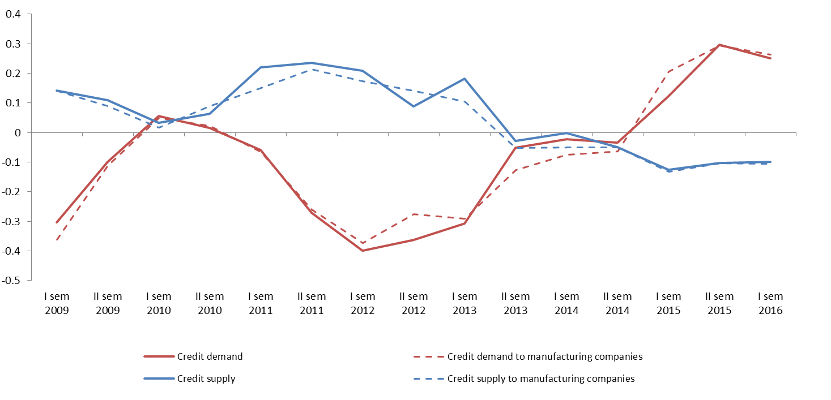
* Diffusion indices a: expansion (+); contraction (-) of credit demand;
* Diffusion Indices b: stiffening (+); loosening (-) of the conditions for credit offer
ª Positive values of the index highlight a demand increase; negative values, a contraction. The diffusion index is composed by adding the qualitative answers of the banks taking part to the survey on the basis of the loans distributed to the companies located in the geographical area. The range field goes from -1 and 1. ^{b} Positive values of the index highlight a stiffening of the offer; negative values indicate a loosening. The diffusion index is composed by adding the qualitative answers of the banks taking part to the survey on the basis of the loans distributed to the companies located in the geographical area. The range field goes from -1 and 1.
Source: Confindustria and SRM elaborations on Banca d’Italia data

Difference of the number of employees between the III trim. 2016 and the III trim. 2017 (absolute values, in thousands)
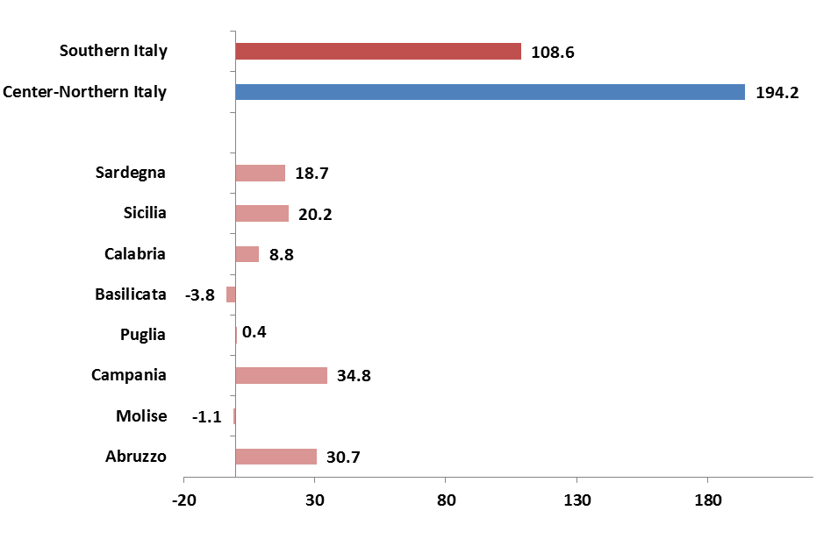
Source: Confindustria and SRM elaborations on Istat data

Bonus employment South: applications approved and confirmed by region category and type up to August 2017
 | Permanent contract | Apprenticeship contract | Transformation of a fixed-term contract into a permanent contract | Total
Abruzzo | 1,496 | 119 | 924 | 2539
Basilicata | 1,904 | 265 | 698 | 2,867
Calabria | 4,359 | 464 | 1,309 | 6,132
Campania | 21,041 | 1,336 | 5,681 | 28,058
Molise | 400 | 35 | 225 | 660
Puglia | 12,328 | 1,137 | 4,598 | 18,063
Sardegna | 3,137 | 166 | 1,387 | 4,690
Sicilia | 14,295 | 911 | 4,436 | 19,642
Southern Italy | 58,960 | 4,433 | 19,258 | 82,651
Source: Confindustria and SRM elaborations on INPS data

Export of Southern provinces (III trimester 2016 – III trimester 2017 data). Values in millions of euro and in percentage
 | III Q | III Q | Var. %  2016-2017 |  |  | III Q | III Q | Var. %  2016-2017
 | 2016 | 2017 |  |  |  | 2016 | 2017
Abruzzo | 6,130.60 | 6,271.90 | 2.3 |  | Catanzaro | 60.7 | 60.8 | 0.2
L'Aquila | 398.4 | 431.5 | 8.3 |  | Reggio Calabria | 128 | 161.1 | 25.9
Teramo | 941.1 | 1,005.70 | 6.9 |  | Crotone | 22.9 | 18.3 | -20.1
Pescara | 406.7 | 413.9 | 1.8 |  | Vibo Valentia | 27.9 | 26.6 | -4.7
Chieti | 4,384.40 | 4,420.80 | 0.8 |  | Sicilia | 5,143.10 | 6,822.70 | 32.7
Molise | 430.3 | 299.4 | -30.4 |  | Trapani | 198 | 189.2 | -4.4
Campobasso | 371.5 | 242.1 | -34.8 |  | Palermo | 205.5 | 204.2 | -0.6
Isernia | 58.8 | 57.3 | -2.5 |  | Messina | 605.9 | 806.6 | 33.1
Campania | 7,481.40 | 7,636.10 | 2.1 |  | Agrigento | 95 | 109.5 | 15.2
Caserta | 857.3 | 841.2 | -1.9 |  | Caltanissetta | 42.3 | 43.3 | 2.5
Benevento | 129.4 | 131.1 | 1.4 |  | Enna | 6.7 | 8.7 | 30.0
Napoli | 3,973.50 | 4,106.60 | 3.3 |  | Catania | 804.7 | 971.6 | 20.7
Avellino | 770.7 | 795.8 | 3.3 |  | Ragusa | 252.8 | 247.3 | -2.2
Salerno | 1,750.60 | 1,761.40 | 0.6 |  | Siracusa | 2,932.20 | 4,242.30 | 44.7
Puglia | 5,824.30 | 6,137.30 | 5.4 |  | Sardegna | 2,929.20 | 3,981.50 | 35.9
Foggia | 572.6 | 550.2 | -3.9 |  | Sassari | 97.2 | 107.5 | 10.5
Bari | 2,818.70 | 3,086.70 | 9.5 |  | Nuoro | 44.7 | 42.2 | -5.7
Taranto | 984.9 | 995 | 1.0 |  | Cagliari | 2,629.90 | 3,594.20 | 36.7
Brindisi | 692.6 | 733.7 | 5.9 |  | Oristano | 41.2 | 40 | -3.0
Lecce | 372.4 | 361.3 | -3.0 |  | Olbia-Tempio | 30.1 | 37.1 | 23.3
BAT | 383.2 | 410.4 | 7.1 |  | Ogliastra | 0.4 | 62.6 | 17510.7
Basilicata | 3,350.00 | 2,801.90 | -16.4 |  | Medio Campidano | 0.1 | 0.2 | 57.0
Potenza | 3,118.20 | 2,553.80 | -18.1 |  | Carbonia-Iglesias | 85.4 | 97.7 | 14.4
Matera | 231.8 | 248.1 | 7.0 |  | Southern Italy | 31,588.0 | 34,288.0 | 8.5
Calabria | 299.2 | 337.2 | 12.7 |  | Italy | 308,328.5 | 330,736.0 | 7.3
Cosenza | 59.6 | 70.4 | 18.1
Source: Confindustria and SRM elaborations on Coeweb data
Manufacturing export of the Mezzogiorno by sector: III trimester 2017 (values in billions of euro and percentage variation)
SECTOR | III Q 2017 | Var. % III Q '16/III Q '17 | III Q 2017 | Var. % III Q '16/III Q '17
 | Southern Italy |  | Center-Northern Italy
Manufacture of food, beverages and tobacco | 3.7 | 0.8 | 24.7 | 7.1
Manufacture of textiles, wearing apparel, leather and related products | 1.8 | 2.7 | 38.2 | 3.8
Manufacture of wood, paper, printing and reproduction | 0.3 | 6.2 | 6.4 | 2.4
Manufacture of coke and refined petroleum products | 7.4 | 42.9 | 9.9 | 38.8
Manufacture of chemicals and chemical products | 1.8 | 21.6 | 22.5 | 10.3
Manufacture of basic pharmaceutical products and pharmaceutical preparations | 2.0 | 9.4 | 17.8 | 13.2
Manufacture of rubber and plastic products and other non-metallic mineral products | 1.4 | 2.5 | 19.9 | 3.9
Manufacture of basic metals and fabricated metal products, except machinery and equipment | 1.9 | 1.3 | 35.0 | 8.4
Manufacture of computer, electronic and optical products; | 0.9 | 8.4 | 10.3 | 4.9
Manufacture of electrical equipment | 0.8 | -10.0 | 17.0 | 4.9
Manufacture of machinery and equipment n.e.c. | 1.9 | 3.6 | 58.9 | 6.2
Manufacture of motor vehicles, trailers, semi-trailers and of other transport equipment | 7.8 | -4.2 | 37.7 | 5.4
Other manufacturing | 0.8 | 2.1 | 19.1 | 5.9
Total Manufacturing | 32.4 | 8.6 | 317.4 | 7.2
Source: Confindustria and SRM elaborations on Istat data

Regional distribution of companies that subscribed to a networking contract (December 2017) 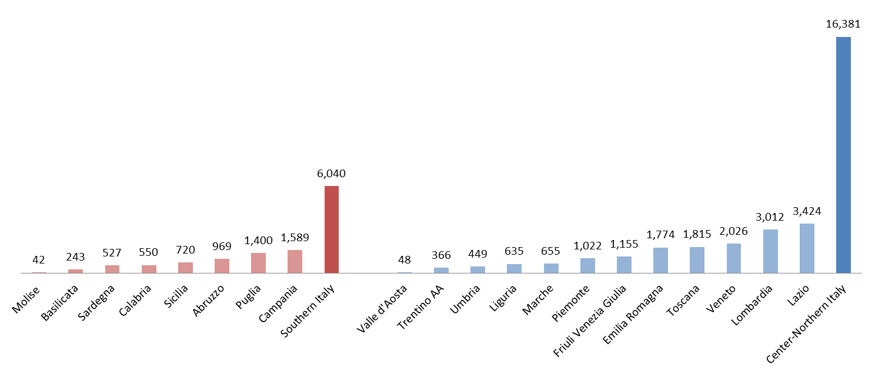
Source: Confindustria and SRM elaborations on Retimpresa and Infocamere data

Innovative Start-ups* in Southern regions, absolute values and % composition (II trimester 2017 vs II trimester 2016)
 | Innovative Start-ups | Innovative Start-ups | % on Italy | Var. %  II Q '16/II Q '17
 | (II Q 2017) | (II Q 2016)
Abruzzo | 177 | 139 | 3.2 | 27.3
Molise | 27 | 21 | 0.5 | 28.6
Campania | 547 | 370 | 9.8 | 47.8
Puglia | 290 | 222 | 5.2 | 30.6
Basilicata | 56 | 46 | 1.0 | 21.7
Calabria | 173 | 136 | 3.1 | 27.2
Sicilia | 368 | 276 | 6.6 | 33.3
Sardegna | 152 | 155 | 2.7 | -1.9
Southern Italy | 1,790 | 1,365 | 24.2 | 31.1
Center-Northern Italy | 5,604 | 4,578 | 75.8 | 22.4
Italy | 7,394 | 5,943 | 100 | 24.4
*Innovative start-ups are capital societies under Italian law, also constituted under cooperative form, or European societies headquartered in Italy and meeting specific criteria whose exclusive or predominant social objective is the development, the production and the marketing of innovative, high-tech products or services. The innovative start-ups are regulated by law n. 221/2012
Source: Confindustria and SRM elaborations on Registroimprese.it data

Tourism arrivals and nights spent in Southern regions (years 2014-2016; absolute values and % var.)
 | Arrivals* |  |  |  | Nights spent**
 | 2014 | 2015 | 2016 | Var. % 15/16 | 2014 | 2015 | 2016 | Var. % 15/16
Abruzzo | 1,411,435 | 1,522,087 | 1,526,452 | 0.3 | 6,282,674 | 6,177,230 | 6,119,103 | -0.9
Molise | 147,109 | 149,202 | 136,948 | -8.2 | 419,597 | 492,018 | 460,007 | -6.5
Campania | 4,632,876 | 5,258,079 | 5,492,496 | 4.5 | 18,060,075 | 18,855,907 | 19,872,576 | 5.4
Puglia | 3,271,410 | 3,434,839 | 3,731,182 | 8.6 | 13,274,254 | 13,526,151 | 14,436,278 | 6.7
Basilicata | 579,111 | 673,774 | 717,280 | 6.5 | 2,100,083 | 2,302,678 | 2,345,626 | 1.9
Calabria | 1,402,373 | 1,482,028 | 1,603,012 | 8.2 | 7,762,931 | 8,151,234 | 8,512,415 | 4.4
Sicilia | 4,621,370 | 4,528,859 | 4,408,499 | -2.7 | 14,866,938 | 14,510,708 | 13,698,160 | -5.6
Sardegna | 2,391,408 | 2,609,692 | 2,879,495 | 10.3 | 11,362,839 | 12,392,827 | 13,485,744 | 8.8
North East | 23,587,108 | 25,795,104 | 25,937,297 | 0.6 | 63,815,398 | 69,105,393 | 69,725,999 | 0.9
North West | 37,171,790 | 39,446,662 | 41,531,950 | 5.3 | 148,653,399 | 153,245,089 | 159,783,873 | 4.3
Central Italy | 27,336,362 | 28,491,811 | 28,979,632 | 1.7 | 91,172,618 | 94,114,835 | 94,522,332 | 0.4
Center-Northern Italy | 88,095,260 | 93,733,577 | 96,448,879 | 2.9 | 303,641,415 | 316,465,317 | 324,032,204 | 2.4
Souther Italy | 18,457,092 | 19,658,560 | 20,495,364 | 4.3 | 74,129,391 | 76,408,753 | 78,929,909 | 3.3
Italy | 106,552,352 | 113,392,137 | 116,944,243 | 3.1 | 377,770,806 | 392,874,070 | 402,962,113 | 2.6
*Number of clients, both Italian and foreigner, hosted in accommodation companies (hotels and complementary businesses included)
**Number of nights
Source: Confindustria and SRM elaborations on Istat data

Expenditure of foreign travellers in the Mezzogiorno regions (years 2016-2017, values in mn of euro and % var.).
 | 2016 |  | 2016 jan-aug |  | 2017 jan-aug |  | Var. 2016/2017
 | Total | of which holidays | Total | of which holidays | Total | of which holidays
Abruzzo | 207 | 92 | 154 | 66 | 126 | 70 | -18.2
Molise | 16 | 4 | 8 | 2 | 11 | 6 | 37.5
Campania | 1,834 | 1,447 | 1,306 | 1,031 | 1,543 | 1,325 | 18.1
Puglia | 557 | 370 | 396 | 266 | 419 | 272 | 5.8
Basilicata | 41 | 26 | 26 | 15 | 22 | 10 | -15.4
Calabria | 177 | 87 | 139 | 73 | 140 | 64 | 0.7
Sicilia | 1,398 | 1,134 | 1,026 | 852 | 1,341 | 1,094 | 30.7
Sardegna | 621 | 487 | 496 | 394 | 804 | 613 | 62.1
Souther Italy | 4,850 | 3,647 | 3,551 | 2,699 | 4,405 | 3,452 | 24.0
Center-Northern Italy | 30,831 | 20,351 | 21,663 | 14,800 | 22,342 | 14,939 | 3.1
Not divisible | 678 | 588 | 524 | 453 | 519 | 453 | -1.0
Italy | 36,359 | 24,586 | 25,738 | 17,951 | 27,267 | 18,844 | 5.9
Source: Confindustria and SRM elaborations on Banca d’Italia data

% variation 2014-2015 of the main structural indicators of tourist companies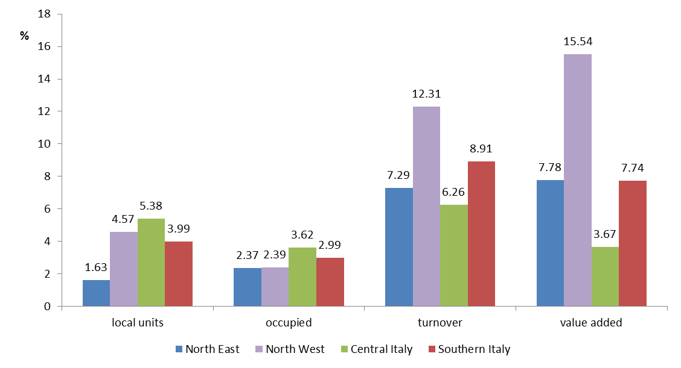
Source: Confindustria and SRM elaborations on Istat data

Profitability indices of hotel companies of the Mezzogiorno (years 2008-2016) 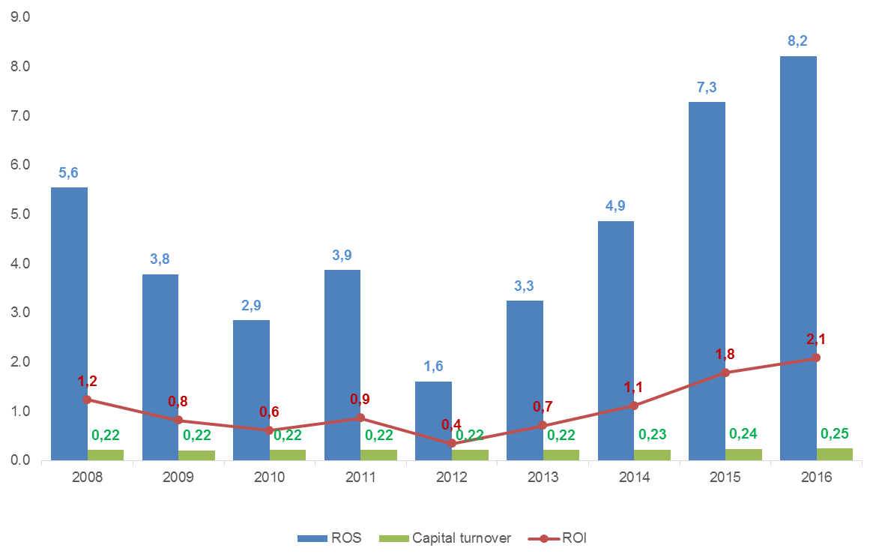
Source: Confindustria Alberghi elaborations on AIDA data

Total turnover and value added of thermal facilities by region (% values, year 2016)
 | Turnover | Value Added
 | Composition %
North West | 9.1 | 8.9
Piemonte | 0.8 | 0.7
Valle d'Aosta | 0.9 | 0.8
Lombardia | 7.2 | 6.9
Liguria | 0.3 | 0.4
North East | 50.5 | 49.1
Trentino Alto Adige | 1.0 | 0.3
Veneto | 34.7 | 34.8
Friuli Venezia Giulia | 0.2 | 0
Emilia Romagna | 14.6 | 13.9
Central Italy | 16.4 | 15.4
Toscana | 11.1 | 10.8
Umbria | 0.5 | 0.5
Marche | 0.9 | 0.7
Lazio | 3.9 | 3.3
Southern Italy | 24.0 | 26.7
Abruzzo | 1.4 | 1.4
Campania | 16.0 | 17.5
Puglia | 1.7 | 2.1
Basilicata | 0.2 | 0.2
Calabria | 1.5 | 1.8
Sicilia | 2.0 | 1.4
Sardegna | 1.3 | 2.4
Italy | 100 | 100
Source: Confindustria and SRM elaborations on company budgets

Regional Innovation Scoreboard, 2017
 |  | Italy= 100 | UE 28 = 100
1 | Friuli Venezia Giulia | 119.2 | 87.8
2 | Emilia Romagna | 108.4 | 79.9
3 | Piemonte | 108.2 | 79.8
4 | Lombardia | 107.6 | 79.6
5 | Veneto | 107.7 | 79.4
6 | Provincia Autonoma di Trento | 106.3 | 78.4
7 | Toscana | 102.4 | 75.5
8 | Umbria | 100.8 | 74.3
9 | Lazio | 99.8 | 73.6
10 | Liguria | 94.4 | 69.6
11 | Provincia Autonoma di Bolzano | 94.2 | 69.4
12 | Marche | 94.1 | 69.4
13 | Abruzzo | 87.5 | 64.5
14 | Molise | 82.8 | 61
15 | Valle d'Aosta | 80 | 59
16 | Puglia | 79.4 | 58.5
17 | Basilicata | 78.6 | 57.9
18 | Campania | 78.4 | 57.8
19 | Calabria | 78.4 | 57.8
20 | Sardegna | 71 | 52.4
21 | Sicilia | 69.7 | 51.3
Source: Confindustria and SRM elaborations on Europea Commission data, (Regional Innovation Scoreboard, 2017)

Young people that prematurely leave school (age 18-24, % values)
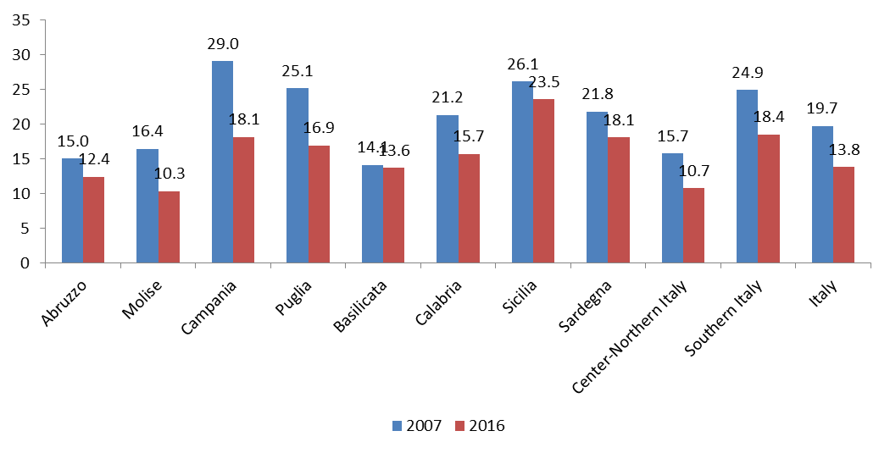
Source: Confindustria and SRM elaborations on Istat data
Incidence of the relative family poverty rate by age of the reference person and geographical distribution (% values, years 2014-2016)
Age class | North Italy |  |  | Central Italy |  |  | Southern Italy |  |  | Italy
 | 2014 | 2015 | 2016 | 2014 | 2015 | 2016 | 2014 | 2015 | 2016 | 2014 | 2015 | 2016
18-34 | 8.4 | 8.3 | 10.7 | 14.7 | 6.8 | n.d. | 24.8 | 23.3 | 23.2 | 14.3 | 12.8 | 14.6
35-44 | 7.7 | 8.2 | 9.3 | 8.4 | 12.5 | 12.3 | 22.4 | 22.4 | 24.4 | 12.4 | 13.5 | 14.6
45-54 | 4.7 | 6.4 | 6.6 | 6 | 6.8 | 9.9 | 20.7 | 23.1 | 21.1 | 10.2 | 11.9 | 11.6
55-64 | 3.2 | 4.6 | 3.6 | 4.4 | 5.5 | 6.9 | 17.6 | 18.4 | 19.2 | 8 | 9 | 9.4
65 and over | 3.3 | 3.1 | 3.3 | 4.1 | 3 | 4.2 | 21.5 | 18.2 | 16.5 | 9.3 | 8 | 7.9
Total | 4.9 | 5.4 | 5.7 | 6.3 | 6.5 | 7.8 | 21.1 | 20.4 | 19.7 | 10.3 | 10.4 | 10.6
Source: Confindustria and SRM elaborations on Istat data

